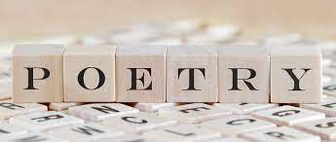

**Poetry Project**

Directions/Rubric: You are going to be completing a poetry project for three poems from this unit on google slides. The three poems are “Avarice” pg. 432, “The Good Life” pg. 434, and “Money” pg. 435. You will read each poem, summarize it, generate three questions and answers, and find images. You will also be comparing and contrasting the three poems. Below you will find the layout and rubric for the project. This will go in the assessment category.

Title Slide /5

First Poem “Avarice” – 2 Slides – first slide is a summary of the poem and an image. The second slide will contain three questions and answers that you generate from the poem (higher level questions) and an image. /10

Second Poem “The Good Life” – 2 Slides – first slide is a summary of the poem and an image. The second slide will contain three questions and answers that you generate from the poem (higher level questions) and an image. /10

Third Poem “Money” – 2 Slides – first slide is a summary of the poem and an image. The second slide will contain three questions and answers that you generate from the poem (higher level questions) and an image. /10

Compare/Contrast Poems – minimum of 3 slides comparing and contrasting the poems (bulleted information) – this is up to you to determine how you want to put this together – be creative. /15

Creativity, not black and white, has a theme, grammar, conventions /10

Total / 60

*10 slides minimum – you can have more if you need.